# DFS Patient Management – User Guide



Contents

DFS Patient Management – User Guide 1

Login 2

Home Page 3

School Screening / Medical Camp Screening 4

New Screening 4

Exporting Referrals 6

Exporting Templates 6

Delete Screening 6

Edit Screening 6

Clinic Screening 7

New/Edit/Delete Clinic Screening 7

Import Clinic Patient Records 7

Templates for Import 7

Reporting 8

Administration 9

User Permissions/Roles 10

## Login



Figure : Login Screen

Request for an account to be created from your administrator. Your administrator will communicate the user name and password to you. Request for changing password/forgot password needs to be routed via your administrator. There is no automated reset mechanism at this point in time.

You have the option to select a theme (or color) from the available choices of Blue or Grey for your application.

Press the Login button to authenticate yourself, if you are successfully authenticated you will be presented with the next screen as below. If you don’t see this screen as below, you will need to check your username and password and ask for a reset with your administrator.

## Home Page

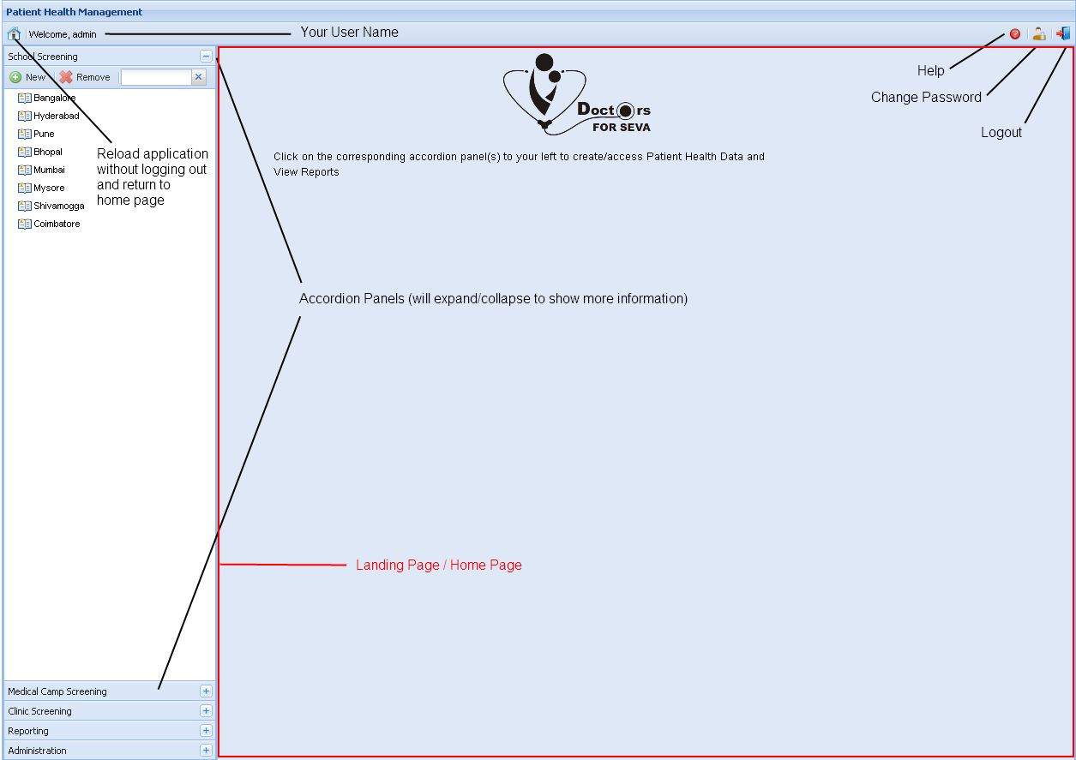

Figure : Home Page

This is the default view you will see when you login to the application. The content in each of the accordion panel’s is determined by the permissions you have that is assigned by your admin.

You have options to logout of the application gracefully, or change your password. The other option that you see to your far left beside your user name is the Home Page button, it will close all the open tasks and return you to the Home page and you will notice it will reload the accordion’s accordingly fetching the most current information from the server.

We have 5 activities that can be performed in the application, they include managing the following:

1. School screening
2. Medical Camp Screening
3. Clinic Screening
4. Reporting
5. Administration

We shall see in brief about the first two tasks now, they have many things in common including the look and feel and usage.

## School Screening / Medical Camp Screening

### New Screening

### 

Figure : New Screening

This is a typical data entry screen that you will see when you click on the ‘New’ button in school screening

There are two ways of recording data into the system

#### Manual Entry

Click the add button on the patient details grid, new row is added at the last. Update the details and click on save button

#### Import

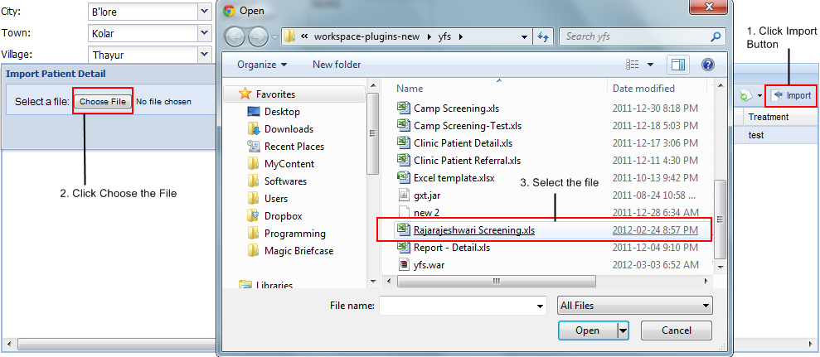

Figure : Step 1 - Screening Import

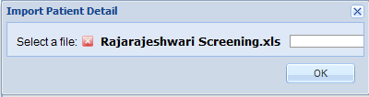

Figure : Step 2 - Screening Import

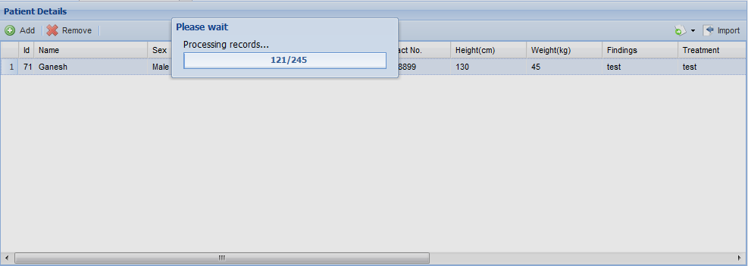

Figure : Step 3 - Screening Import

After records are processed, they are available in the Patient Details grid. Note: If it is not a new screening records will be merged by default, new screening will take in all the records without merging

### Exporting Referrals

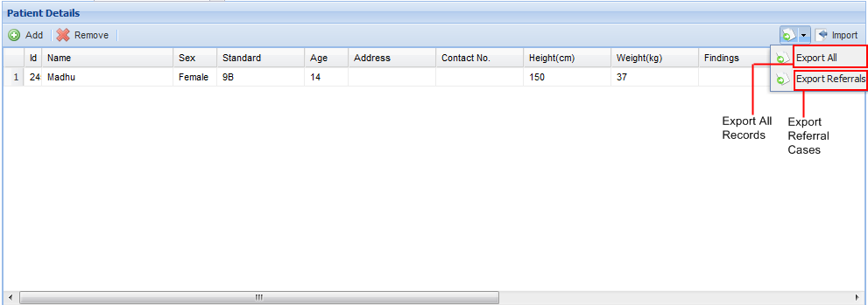

Figure : Export Options

Exporting referrals is done through export referrals option; it will export all the records to Excel spreadsheet that have either Referral1 or Referral2 column populated

### Exporting Templates

Click on export all option on a new screening detail screen (an empty grid) this will give you a template that has to be used while you import records back. Note: Records should start at Row 1, column 1; header should be the first row. You may need to delete few rows/columns from the exported excel sheet.

### Delete Screening

Select the event in the accordion panel under Camp/School screening (the date of the event) and click on the remove button on the accordion. The selected event will be deleted. Note: It cannot be restored.

### Edit Screening

Search for the chapter and project name and locate the event date, click on that event. Wait for the event details to be retrieved to start editing. You will not be able to change the chapter, project and date, all other fields are editable.

## Clinic Screening

### New/Edit/Delete Clinic Screening

There are two grids as shown below, namely Patient Details and the other grid below that will capture Patient Referral History. Note: The second grid – Referral History grid activates based on selecting a particular patient only.

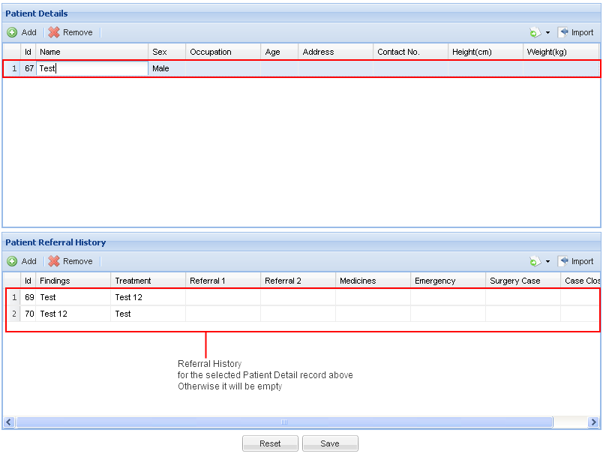

Figure : Clinic Screening Layout

### Import Clinic Patient Records

Import and export are similar to the Camp/Medical Screening. Refer to the sections on that above.

### Templates for Import

Templates can be obtained for each of the grids by doing an export, this will give out a excel file. This can be used to fill data for import back. Note: Data should start at Row 1, Column 1 starting with the header in the first row.

## Reporting

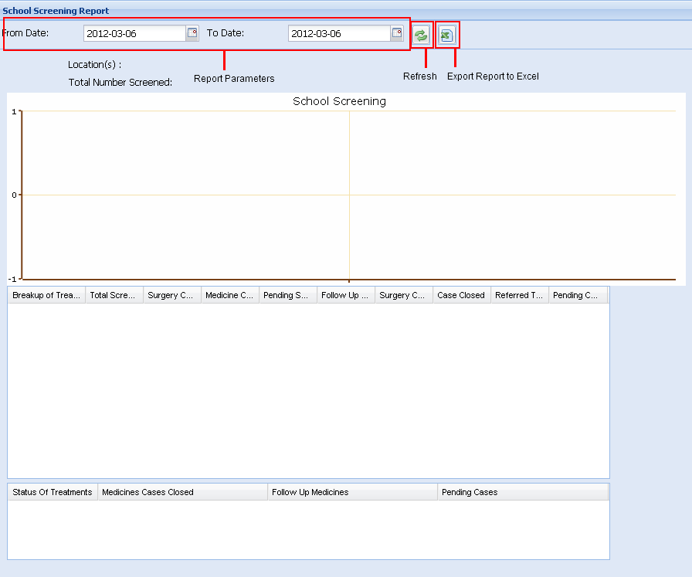

Figure : Report Layouts

This is the general layout of the report screen, you need to select the report parameters and click on refresh button to get the data. You will see the graph plotted and the data used to plot it in the grid below, a summary grid is available after that.

An option to export the report – along with the graph plotted is exported to excel when this option is exercised.

## Administration

Following entities are available for administration. You can add/remove and edit these entities if you have permissions to manage them.

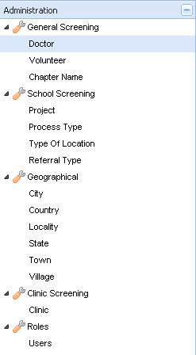

Figure : Entities that can be administered

### User Permissions/Roles

User Administration helps you add more users into the system and assign permissions to them. Special user called admin exists who is the super user or administrator that doesn’t need any permissions to be assigned even if it is assigned – it will be ignored. This special user called ‘admin’ has access to all the screens and he can Read/Write/Delete all entities.

Here are the permissions and their scope:

Read – allows read only access to the specified entity

Write – allows edit/writing to the specified entity

Delete – allows removal of the specified entity

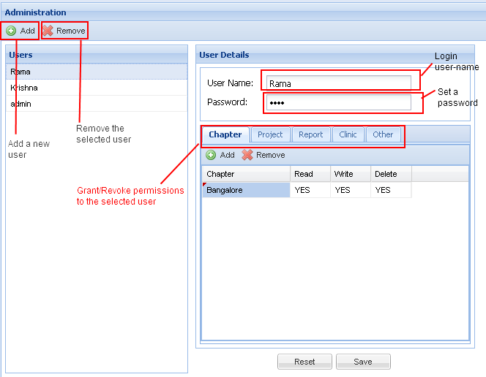

Figure : User Permissions

Note: Chapter and Project should be assigned together, only assigning chapter will not automatically allow all projects under it to be managed. ‘Other’ permissions is required for managing the entities that you can see in Figure 10